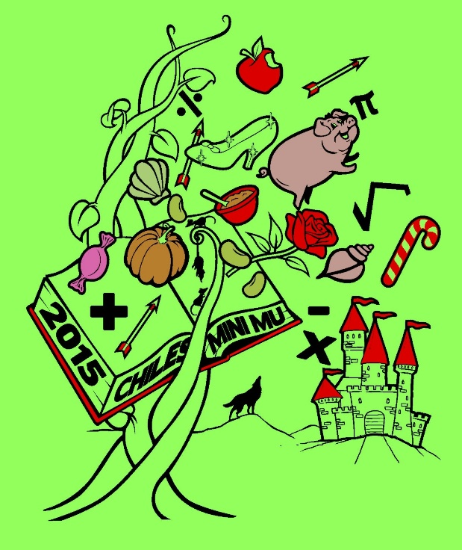

**2015**

**CHILES MINI MU**

**12 December 2015**

**Lawton Chiles High School**

**Hosted by Chiles Mu Alpha**

**Theta**

**ALGEBRA I**

**SESSION 2**

**THREES**

Once upon a time, in a land far away, there was a kingdom of threes. Everything was in triplets. Three houses to a block, three mailboxes to a house, even three letters per mailbox. So what’s your favorite number? As a resident of this kingdom, mine is three too. Which is why I wrote this test all about it. You have 60 minutes to complete the following 30 multiple-choice questions. Choices A through D are answer choices for every problem. Choice E stands for “none of the above,” or NOTA. Scoring is as follows: 5 points for a correct answer, 1 point if left unanswered, and 0 points for an incorrect response. Units are assumed. Good luck and have fun!

